TEXT REFERENCE: pages____ to _____

Worksheet to Follow YouTube Learning Day
You can use the notes you took during the lesson but that is it!
Muscle Mechanics Part One:
- What is a graded muscle response?

- What are the two factors that influence the muscle contraction?
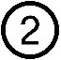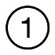

- What is a MUSCLE TWITCH?

- What is a MOTOR UNIT?

- There are THREE PHASES of a Muscle Twitch, what are they? Draw and Label these phases on the Graph below.
WHAT IS HAPPENING IN EACH PHASE?

1.

Tension (N)

2.

3.

Time (ms)

- What is TETANUS?

- What is MAX TENSION (numerically and explained)

- Explain what is happening regarding the THREE PHASES mentioned above.

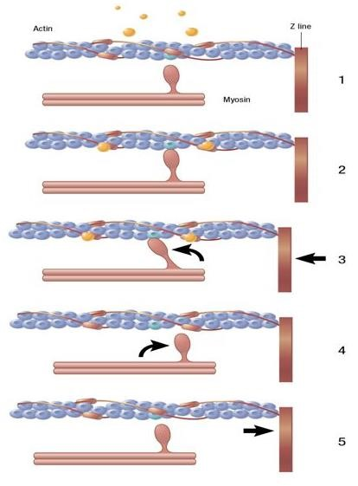
WHAT IS HAPPENING AT THE SARCOMERE LEVEL WITH REGARD TO THE 3 PHASES:
1.

2. CROSSBRIDGES

3. POWERSTROKE

4.

- If the load is greater that the muscle can handle (aka not enough power) what will happen at the sarcomere level to the ACTIN and MYOSIN?

- The Muscle will contract if the load/resistance is ____________________________ to activate or shorten the Actin and Myosin.
TETANUS
- What happens if the muscle does not reach maximum tension and there is another stimulus?
- Draw three different motor neurons and three different stimuli on the graph below. The Stimuli come at 10ms, 30ms, and 50ms.
- Explain what is happening in this graph and explain what happens with REPOLARIZATION?



Time (ms)

Tension (N)

EYE MUSCLE vs CALF MUSCLE: Explain the difference between these two contractions.

FREQUENCY OF A MUSCLE TWITCH

Explain in your own words what the frequency of a MUSCLE TWICH accomplishes for the muscle fibre.

SUMMATION OF WAVES
There are 2 types of TENTANUS. Explain and Draw a diagram of each.

- INCOMPLETE OR UNFUSED (This is a DAILY occurrence)
SMOOTH OR QUIVERING?

Example:

- COMPLETE OR FUSED (This does NOT happen every day)

SMOOTH OR QUIVERING?
Example:

Why when you hit a PLATEAU at MAX TENSION, are you not able to go any further? (Hint, Actin and Myosin)

1

2
4

3

STRENGTH OF A MUSCLE TWITCH

- 10mV is there an observable contraction? Y or N
- 30mV is there an observable contraction? Y or N
- 1000 mV is there an observable contraction? Y or N
- 2000 mV is there an observable contraction? Y or N

When was the first OBSERVABLE contraction?
What does that mean this must be? ______________________

What is the difference between 3 and 4? What happened to the muscle contraction?

MAXIMAL STIMULUS = MAXIMAL AMOUNT OF FORCE THAT THIS MUSCLE FIBRE CAN PRODUCE
Draw the two Graphs below

VOLTAGE vs TENSION

RMP RMP
THRESHHOLD

MAX TENSION OR FORCE

THRESHHOLD

MAX STIMULUS

Time ms Time ms
RMP = resting membrane potential

HOW DOES VOLTAGE EFFECT TENSION?

The more MOTOR UNITS there are, the more __________________________ the contraction.
Fine-tuned movement requires __________________________________.

SIZE PRINCIPLE
- SMALL MUSCLE FIBRES are RECRUITED for __________________________ muscle contractions.

- Why are these muscle fibres recruited first? They have the MOST ___________________________ motor neurons!

- They have a __________________ Threshold Potential

- Are they QUICK or SLOW contractions?

- Do they generate a lot of FORCE?

Explain what happened to VINCENSO in your own words.

Summarize Motor Unit Recruitment regarding threshold, size and generated force.

What is multiple MOTOR UNIT recruitment or summation in your own words.

